healthy_relationships

Kevin Gilds, MPA

May 28, 2016

`

## girlCode council.x hr.avg.x council.y hr.avg.y  
## 1 313DW060502 Gateway Council 2.850 Gateway Council 4.650  
## 2 313GR040203 Gateway Council 4.700 Gateway Council 5.700  
## 3 313JP090103 Gateway Council 5.000 Gateway Council 6.000  
## 4 313JB090402 Gateway Council 5.625 Gateway Council 5.700  
## 5 313JG070402 Gateway Council 5.000 Gateway Council 5.325  
## 6 313JB091302 Gateway Council 4.700 Gateway Council 5.250

## 'data.frame': 330 obs. of 5 variables:  
## $ girlCode : chr "313DW060502" "313GR040203" "313JP090103" "313JB090402" ...  
## $ council : chr "Gateway Council" "Gateway Council" "Gateway Council" "Gateway Council" ...  
## $ Pre : num 2.85 4.7 5 5.62 5 ...  
## $ council.y: chr "Gateway Council" "Gateway Council" "Gateway Council" "Gateway Council" ...  
## $ Post : num 4.65 5.7 6 5.7 5.33 ...

|  |  |  |
| --- | --- | --- |
|  | FALSE | TRUE |
| **M1** | 0.364 | 0.635983263598326 |
| **M2** | 0.2818 | 0.718204488778055 |
| **M3** | 0.2212 | 0.778787878787879 |

|  |  |
| --- | --- |
|  | TRUE |
| **M3** | 1 |

## [1] 244

##   
## M1 M2 M3   
## 59 97 88

|  |  |
| --- | --- |
|  | TRUE |
| **M1** | 1 |
| **M2** | 1 |
| **M3** | 1 |

## Healthy Relationship Outcome

Relationship skils are a critical component of success in all realms of life. The Healthy Relationship questions measures the behaviors and attitudes of the respondent regarding their relationship skills. Questions that measure healthy relationships skills include the following:

*Healthy Relationship Questions*

1. If I have a serious problem, I have people to talk with.
2. I let people know if they have hurt my feelings.
3. I let my friends know when I think they are good at something.
4. In any relationship - romantic or not - I make it clear when I don't feel comfortable.

The number of pre and post survey that could be matched is **330**.

1. The number of students who achieved at a high level is **257**:
2. The number of studens who did not achieve at high level but increased outcome socre **23**:

The percent of students with a successful outcome is **84.85%**

The improvement in outcome scores is graphically represented below.

hr_2016 <- hr_all %>%  
 filter(Year_Id =="M3")

pre_hr_histq <- qplot(hr_2016$Pre, geom="histogram", main= "Pre Survey", bins=40, xlab="Outcome Scores", bins=40) + geom_vline(xintercept = 4.45, col="red")   
  
  
post_hr_histq <-qplot(hr_2016$Post, geom="histogram", main= "Post Survey", bins=40, xlab="Outcome Scores", ylim=c(0,40)) + geom_vline(xintercept = 4.45, col="red")  
  
grid.arrange(pre_hr_histq, post_hr_histq, ncol=2)

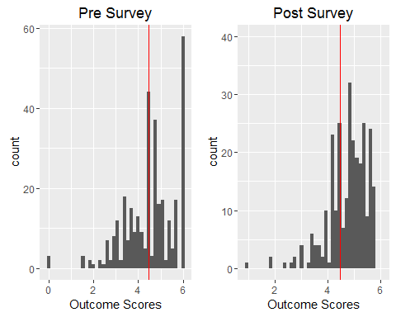

The percent of students who achieved the healthy releationship at a high level is **77.88%**. The imrovement is represented graphically below.

hr_bar_pre <-qplot(hr_2016$Pre >=4.45, geom="bar", ylim=c(0, 200), main="Pre survey Results", xlab="Achievment at High Level")  
  
hr_bar_post <-qplot(hr_2016$Post >=4.45, geom ="bar", main="Post Survey Results", xlab="Achievment at High Level")  
  
grid.arrange(hr_bar_pre, hr_bar_post, ncol=2)

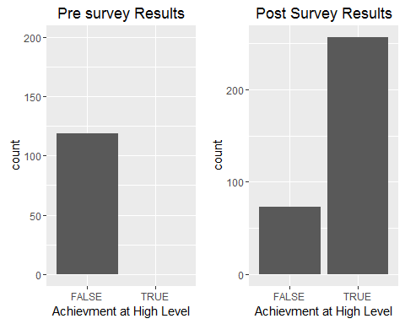

healthy_change <- filter(healthy_prepost, Pre !=6.0 & Post !=6.0)

The percent of students who went from low achievment to high achievement **26.67%**. The number of students who had the opportunity to improve their healthy relationship outcome score is **238**, and the mean increase in outcome score is **0.5244748**

The increase in the healthy relationship outcome scores is represented graphically below. Marks to the right of the veticial red line represents an increase in the outcome score. Marks above the horizintal line represents scores above the high and low achievement.

healthy_change_p <- ggplot(hr_2016,(aes(x=hr.diff, y=Pre)))  
healthy_change_p + geom_count() + geom_hline(yintercept = 4.45) + geom_vline(xintercept = 0, col="red") + labs(x="Pre and Post Difference", y="Pre Outcome Score", title="Healthy Releationship Survey Results")

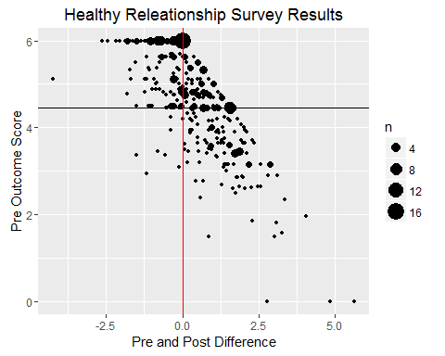

A wilcox.test was administered on the healthy relationship outcome data and the results show that the

pander(wilcox.test(hr_2016$Pre, hr_2016$Post))

Wilcoxon rank sum test with continuity correction: hr_2016$Pre and hr_2016$Post

|  |  |  |
| --- | --- | --- |
| Test statistic | P value | Alternative hypothesis |
| 42887 | 2.203e-06 * * * | two.sided |

cohen.d(hr_2016$Post, hr_2016$Pre, paired=TRUE)

##   
## Cohen's d  
##   
## d estimate: 0.3316444 (small)  
## 95 percent confidence interval:  
## inf sup   
## 0.1774961 0.4857928

## Cross Validation of Healthy Relationship Skills

Survey results from teachers and parents also provide evidence that the Get REAL! program helps students increase their relationship skills. Below are tables that provide a breakdown of questions on the post survey from the parent and teacher surveys. The pattern again shows improvement in moderate agreement with the question being both with the parent survey and teacher survey.

Parent Survey Question 1: She develops positive relationships with her classmates.

pre_parent <- dbReadTable(getReal_2016db, "pre_parent")  
  
post_parent <- dbReadTable(getReal_2016db, "post_parent")

Pre Parent Survey

Quetion:She develops positive relationships with her classmates.

names(pre_parent)

## [1] "ResponseID"   
## [2] "ResponseSet"   
## [3] "StartDate"   
## [4] "EndDate"   
## [5] "Finished"   
## [6] "council"   
## [7] "girlCode"   
## [8] "schoolName"   
## [9] "Time"   
## [10] "graduate"   
## [11] "sheHasSelfConfidence"   
## [12] "goodAttitudeAboutSchool"   
## [13] "readsBooksForFun"   
## [14] "positiveRelationships"   
## [15] "homeworkWithoutSupervision"   
## [16] "helpedMyDaughterGainConfidenceInHerAbilities"   
## [17] "helpedMyDaughterAchieveSuccessInSchool"   
## [18] "helpedHerEstablishPostiveRelationshipsWithHerClassmates"  
## [19] "helpedYourDaughterAchieveSuccessInSchool"   
## [20] "ImproveTheGetRealProgram"   
## [21] "X"

pre_parent_hr1 <- pre_parent %>%  
 select(14)  
  
colnames(pre_parent_hr1) [1] <- "Q5"  
  
names(pre_parent_hr1)

## [1] "Q5"

pre_parent_hr1$Q5 <- factor(pre_parent_hr1$Q5, levels=c("Strongly Disagree", "Disagree", "Slightly Disagree", "Neither Agree/Disagree", "Slightly Agree", "Agree", "Strongly Agree"),ordered = TRUE)  
  
head(pre_parent_hr1)

## Q5  
## 1 Neither Agree/Disagree  
## 2 Neither Agree/Disagree  
## 3 Neither Agree/Disagree  
## 4 Neither Agree/Disagree  
## 5 Neither Agree/Disagree  
## 6 Neither Agree/Disagree

pre_parent_tbl <- table(pre_parent_hr1) #test q5   
  
nrow(pre_parent_hr1) #test to figure how total with testing %s

## [1] 466

pander(pre_parent_tbl)

Table continues below

|  |  |  |  |
| --- | --- | --- | --- |
| Strongly Disagree | Disagree | Slightly Disagree | Neither Agree/Disagree |
| 0 | 1 | 6 | 44 |

|  |  |  |
| --- | --- | --- |
| Slightly Agree | Agree | Strongly Agree |
| 24 | 107 | 284 |

pre_parent_hr1 <- likert(pre_parent_hr1)  
  
summary(pre_parent_hr1) #test

## Item low neutral high mean sd  
## 1 Q5 1.502146 9.44206 89.05579 6.321888 1.042863

plot(pre_parent_hr1, type="heat") + ggtitle("Pre Parent Survey Question 5") + theme_dark()

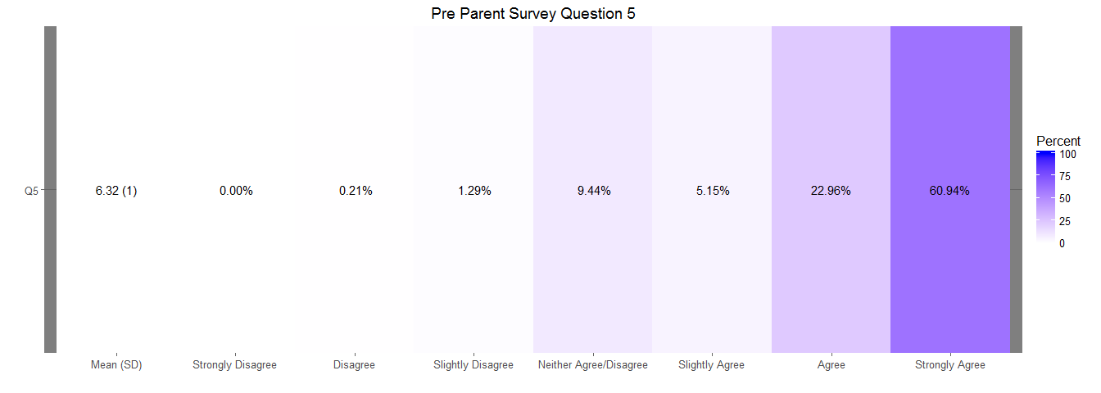

## Post Parent Survey

Question 5: She develops positive relationships with her classmates

Question 9: The Get REAL! program helped my daughter establish positive relationships with her classmates

names(post_parent)

## [1] "ResponseID"   
## [2] "ResponseSet"   
## [3] "StartDate"   
## [4] "EndDate"   
## [5] "Finished"   
## [6] "council"   
## [7] "girlCode"   
## [8] "schoolName"   
## [9] "Time"   
## [10] "graduate"   
## [11] "sheHasSelfConfidence"   
## [12] "goodAttitudeAboutSchool"   
## [13] "readsBooksForFun"   
## [14] "positiveRelationships"   
## [15] "homeworkWithoutSupervision"   
## [16] "helpedMyDaughterGainConfidenceInHerAbilities"   
## [17] "helpedMyDaughterAchieveSuccessInSchool"   
## [18] "helpedHerEstablishPostiveRelationshipsWithHerClassmates"  
## [19] "helpedYourDaughterAchieveSuccessInSchool"   
## [20] "ImproveTheGetRealProgram"   
## [21] "X"

colnames(post_parent) [14] <-"Q5"  
colnames(post_parent) [18] <-"Q9"  
  
  
post_parent_hr1 <- post_parent %>%  
 select(14, 18)  
  
  
names(post_parent_hr1)

## [1] "Q5" "Q9"

post_parent_hr1$Q5 <- factor(post_parent_hr1$Q5, levels=c("Strongly Disagree", "Disagree", "Slightly Disagree", "Neither Agree/Disagree", "Slightly Agree", "Agree", "Strongly Agree"),ordered = TRUE)  
  
post_parent_hr1$Q9 <- factor(post_parent_hr1$Q9, levels=c("Strongly Disagree", "Disagree", "Slightly Disagree", "Neither Agree/Disagree", "Slightly Agree", "Agree", "Strongly Agree"),ordered = TRUE)  
  
  
post_parent_tbl_5 <- table(post_parent_hr1$Q5) #test Q5  
  
pander(post_parent_tbl_5)

Table continues below

|  |  |  |  |
| --- | --- | --- | --- |
| Strongly Disagree | Disagree | Slightly Disagree | Neither Agree/Disagree |
| 0 | 2 | 1 | 4 |

|  |  |  |
| --- | --- | --- |
| Slightly Agree | Agree | Strongly Agree |
| 6 | 85 | 146 |

post_parent_tbl_9 <- table(post_parent_hr1$Q9) #test Q9  
  
pander(post_parent_tbl_9) #return value of test #9

Table continues below

|  |  |  |  |
| --- | --- | --- | --- |
| Strongly Disagree | Disagree | Slightly Disagree | Neither Agree/Disagree |
| 0 | 1 | 1 | 1 |

|  |  |  |
| --- | --- | --- |
| Slightly Agree | Agree | Strongly Agree |
| 3 | 58 | 179 |

nrow(post_parent_hr1) #number of rows to help with testing %s

## [1] 244

head(post_parent_hr1)

## Q5 Q9  
## 1 Disagree Disagree  
## 2 Neither Agree/Disagree <NA>  
## 3 Strongly Agree Strongly Agree  
## 4 Strongly Agree Strongly Agree  
## 5 Agree Strongly Agree  
## 6 Strongly Agree Strongly Agree

post_parent_hr1 <- likert(post_parent_hr1)  
  
summary(post_parent_hr1)

## Item low neutral high mean sd  
## 2 Q9 0.8230453 0.4115226 98.76543 6.687243 0.6305922  
## 1 Q5 1.2295082 1.6393443 97.13115 6.495902 0.7830401

plot(post_parent_hr1, type="heat") +ggtitle("Post Parent Survey Question 5 & Question 9") + theme_dark()

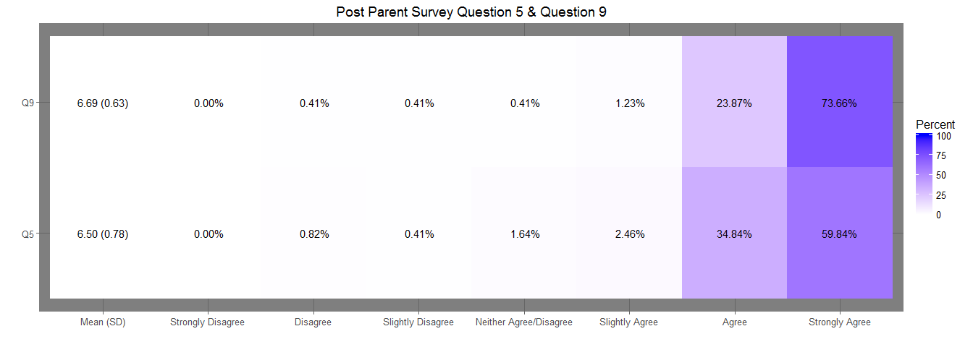

# Teacher Post Survey

Teacher Survey

Question 1: She has developed positive relationships with her classmates

Question 2: The Get REAL! program helped her develop positive relationships with classmates.

post_teacher <- dbReadTable(getReal_2016db, "post_teacher")  
  
names(post_teacher)

## [1] "ResponseID"   
## [2] "ResponseSet"   
## [3] "StartDate"   
## [4] "EndDate"   
## [5] "Finished"   
## [6] "council"   
## [7] "girlCode"   
## [8] "school"   
## [9] "Time"   
## [10] "graduate_ts"   
## [11] "hasConfidence"   
## [12] "goodAttitude"   
## [13] "isInterestedReading"   
## [14] "postivelyParticpates"   
## [15] "completesHomework"   
## [16] "positive_relationships"   
## [17] "helpedHerIncreasedHerSelfConfidence"  
## [18] "helpedHerAchieveSucessInSchool"   
## [19] "helpedHerDevelopPostiveRelationship"  
## [20] "benefitsFromParticipating"   
## [21] "whatCouldBeDoneToImroveTheProgram"   
## [22] "X"

colnames(post_teacher) [16] <- "Q7"  
colnames(post_teacher) [19] <- "Q10"  
  
post_teacher_tbl <- post_teacher %>%  
 select(16, 19)  
  
names(post_teacher_tbl)

## [1] "Q7" "Q10"

post_teacher_tbl$Q7 <- factor(post_teacher$Q7, levels=c("Strongly Disagree", "Disagree", "Slightly Disagree", "Neither Agree/Disagree", "Slightly Agree", "Agree", "Strongly Agree"),ordered = TRUE)  
  
post_teacher_tbl$Q10 <- factor(post_teacher$Q10, levels=c("Strongly Disagree", "Disagree", "Slightly Disagree", "Neither Agree/Disagree", "Slightly Agree", "Agree", "Strongly Agree"),ordered = TRUE)  
  
  
post_teacher_tbl_q7 <- table(post_teacher_tbl$Q7)  
  
pander(post_teacher_tbl_q7) #test teacher post q7

Table continues below

|  |  |  |  |
| --- | --- | --- | --- |
| Strongly Disagree | Disagree | Slightly Disagree | Neither Agree/Disagree |
| 0 | 0 | 0 | 0 |

|  |  |  |
| --- | --- | --- |
| Slightly Agree | Agree | Strongly Agree |
| 0 | 172 | 207 |

post_teacher_tbl_q10 <- table(post_teacher_tbl$Q10)  
  
pander(post_teacher_tbl_q7) #test teacher post q10

Table continues below

|  |  |  |  |
| --- | --- | --- | --- |
| Strongly Disagree | Disagree | Slightly Disagree | Neither Agree/Disagree |
| 0 | 0 | 0 | 0 |

|  |  |  |
| --- | --- | --- |
| Slightly Agree | Agree | Strongly Agree |
| 0 | 172 | 207 |

nrow(post_teacher_tbl) #check to determine number of rows; what to divide to get %

## [1] 398

post_teacher_tbl <- likert(post_teacher_tbl)  
  
summary(post_teacher_tbl)

## Item low neutral high mean sd  
## 1 Q7 0 0 100 6.546174 0.4985215  
## 2 Q10 0 0 100 6.731383 0.4438308

plot(post_teacher_tbl, type="heat") + ggtitle("Post Teacher Survey Question 5 & Question 7") + theme_dark()

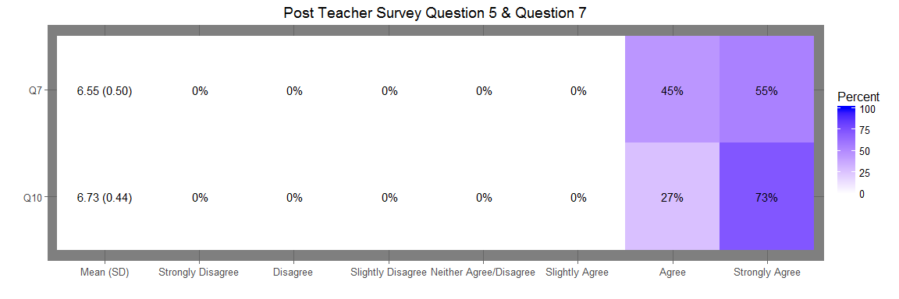

# Trend Data

### Healthy Relationships Outcome Distribution , Plots